Pristine Home
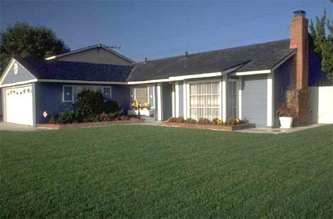
Features and Facts
Largest plan in neighborhood
.47 acre premium lot
Brick foundation
Vaulted ceiling
Open dining area
Ample closet space
Floored attic for storage
Atrium doors to deck
Tiled fireplace
Wood pile
Aluminum gutters
Fiberglass shingles
Central heating
Dishwasher and range
Double pane windows
Municipal water/sewer
Upgrades and what they cost
Granite countertops $ 4500
Privacy fence 2500
Security System 1100
Plantation shutters 2500
Appliances - stainless 3000
Carpeting 4000

Our home is in pristine condition. We are moving to another part of town due to travel time to work. We have enjoyed the friendly neighbors who have become very good friends. Kids as well as adults have a great time living here.
Room Sizes
Family room - 16’3” x 16’1”
Dining room - 12’ x 9’6”
Kitchen - 9’9” x 9’5”
Master bedroom - 12’1” x 11’11”
Bedroom - 12’1” x 11’11”
Bedroom - 11’11” x 11’11”
Total = 1293 sq. feet
Schools Nearby
School of Fine Art
Graphic Design Institute
Costs
Asking price: $226,500
Property taxes: $1,811
Utilities: $150/month
123 Brock Street
Lawrenceville, GA 30004
Call the owner to see
(770) 555-0123

Floor plan
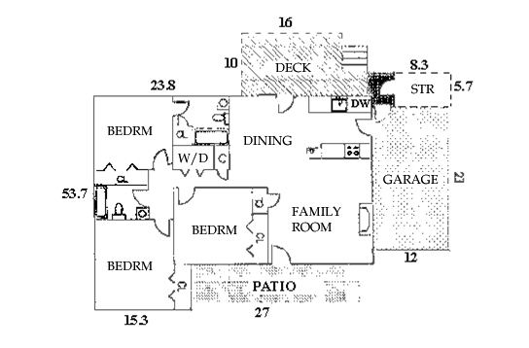

Location Map

